Name: | ___________________________________________________ |  |  | Date: ___________
 | Year 9 Mathematics  Test 4, 2015  Topics – Probability |  |  | 55+2  = %
Total Time: | 55 minutes | Bonus Marks for Notes Sheet   0 mark – No notes sheet   1 mark – Basic notes sheet (little information)   2 marks – Detailed, relevant notes sheet
Weighting: | ______% of the year.
SECTION 1: CALCULATOR FREE
Working: | 24 minutes | Marks for Section 1: | 24
Equipment Allowed: | Nil

1. | [3 marks: 1, 1, 1]
 | Fill in the missing words in the statements below.
probability Venn diagram outcome union intersection
set chance certain impossible random
a) | A two-way table can be used to work out the ____________________ of an outcome occurring from separate events.
b) | A ∩ B represents the ____________________ of A and B and includes the outcomes that are in both A and B.
c) | An event for which the probability is 1 is said to be ____________________ .

2. | [3 marks: 1, 1, 1]
Kelsey collects troll dolls which she keeps in a basket in her room. There are 8 blue ones, 5 green ones and 7 yellow ones.

If she picks one out of her basket at random, what is the probability that:
a) | the troll doll is blue?
b) | the troll droll is yellow?
c) | the troll doll is not green?

3. | [2 marks]
 | If one letter is selected at random from those making up the word SALUTATION, what is the probability that it is not a T or an A?

4. | [6 marks: 1, 1, 1, 1, 1, 1]
You have asked your friends some questions and summarised their answers in the Venn diagram shown below. The questions asked were:
- Who has a prepaid mobile telephone?
- Who has been on an overseas holiday in the last 12 months?
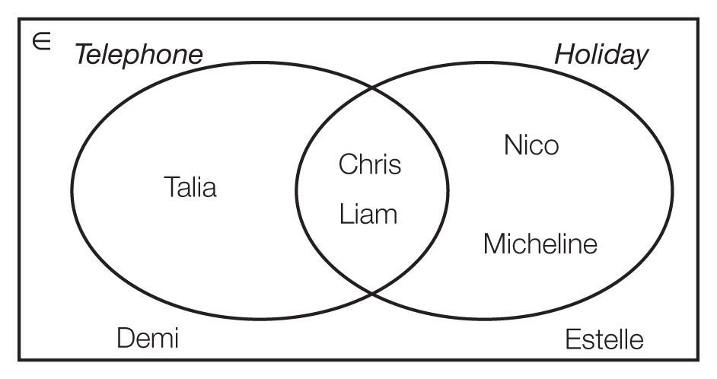

 | Use the Venn diagram to answer the following questions:
a) | How many friends have a prepaid mobile telephone?
b) | How many friends have had an overseas holiday in the last 12 months?
c) | How many friends have a prepaid mobile telephone and have had an overseas holiday in the last 12 months?
d) | How many friends have had a prepaid mobile telephone or had an overseas holiday in the last 12 months?
e) | How many friends do not have a prepaid mobile telephone?
f) | How many friends have neither a prepaid mobile telephone nor have had an overseas holiday in the last 12 months?

5. | [2 marks]
 | Place the following information in the Venn diagram below:
30 Year 8 students were surveyed about who played cricket and football.
10 students stated they did not play cricket or football.
13 students played cricket.
12 students played football.

 | 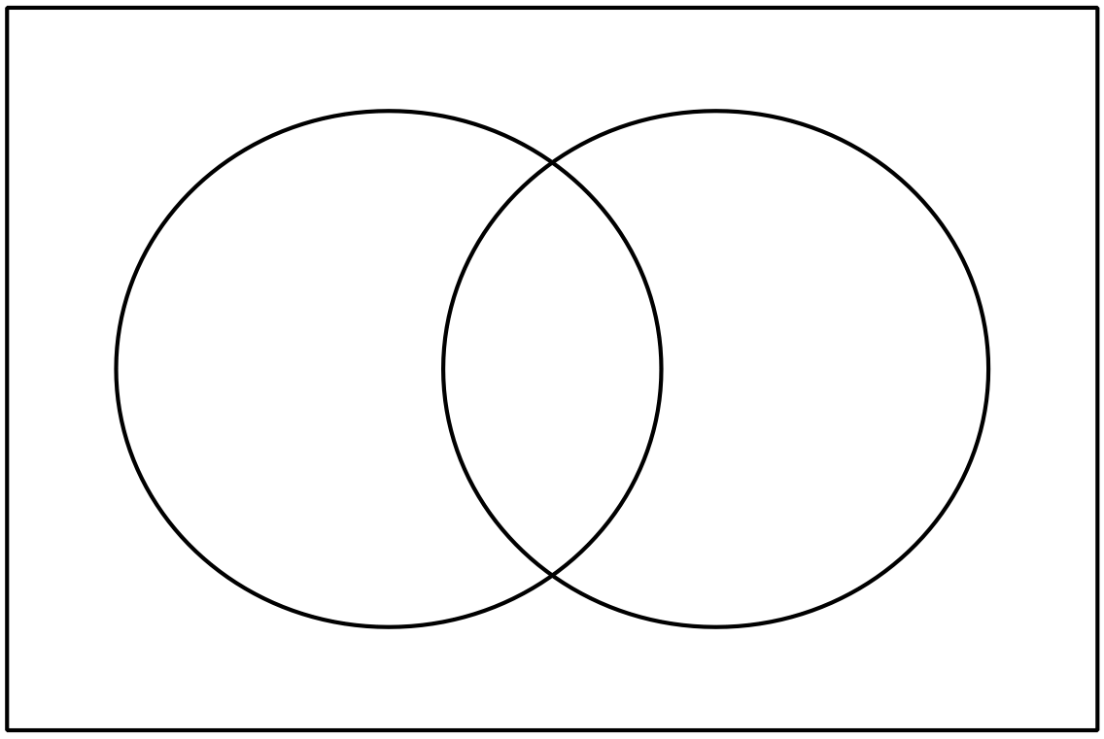

6. | [4 marks: 1, 1, 2]
 | A random number generator is used to simulate the rolling of a normal die. The following results were obtained for 36 rolls of the die.
1 2 2 1 1 1 4 4 5 6 2 6
4 3 4 3 6 1 5 2 2 4 3 4
1 1 6 5 5 6 2 1 6 2 6 3

b) | What is the probability that an even number is generated?
c) | What is the probability that a multiple of 3 is generated?
d) | Do you think another set of 36 results would give the same frequencies? Explain your answer.

7. | [4 marks: 2, 1, 1]
 | Jack is always looking for cheap petrol during the week to fill his car up and save money. After years of research, he has found that Tuesday, Wednesday or Thursday are the cheapest days of the week for petrol. He also found that it is only cheap on one day of the week. Jack now only fills up on one of these days.
a) | Draw the tree diagram displaying the days Jack fills up his car over two weeks.
b) | What is the probability that for two weeks Wednesday is always the cheapest day for petrol?
c) | What is the probability that for two weeks a day starting with T is the cheapest day for petrol?

~ END OF TEST SECTION 1 ~

Name: | ___________________________________________________ |  |  | Date: ___________
SECTION 2: CALCULATOR ASSUMED
Working: | 31 minutes | Marks for Section 2: | 31
Equipment Allowed: | ½ page notes (A4 one side), Scientific calculator

8. | [4 marks: 1, 1, 1, 1]
A bowl contains 26 small identical tiles each marked with a different letter of the alphabet. The following sets have been defined.

A = {vowels} B = {consonants} C = {a, b, c, d, e, f} D = {q, w, e, r, t, y, u, i, o, p}

 | State whether or not each of the following pairs of sets are mutually exclusive.
 | a) | A and B |  | b) | A and C
 | c) | C and D |  | d) | B and C

9. | [3 marks: 1, 1, 1]
 | The two way table below shows the numbers of males and females in a survey who were carrying a mobile phone when interviewed.

 | Male | Female | Total
Carrying Phone | 12 |  | 36
Not Carrying Phone |  | 10
Total | 34 | 34

a) | Complete the missing values in the table above.
b) | One of the people who took part in the survey is chosen at random. What is the probability that the person was a male who was carrying a phone?
c) | If one of the people who were not carrying a phone is chosen at random, what is the probability that the person is a female?

10. | [2 marks: 1, 1]
 | Rhonda and Michelle like playing Words with Friends online. Michelle has won 15 of the last 25 games played. Using these past results as a guide, estimate the probability that the next game is won by:
a) | Rhonda | b) | Michelle

11. | [8 marks: 3, 1, 1, 1, 1, 1]
 | In a board game, two dice are rolled together. One die is six sided with the letters A, B, C, D, E and F on the faces and the other die is four sided with the numbers 1, 2, 3 and 4 on the faces.
a) | Complete the grid below to give the possible outcomes
 | 1 | 2 | 3 | 4
A
B |  | B2
C
D
E |  |  |  | E4
F

b) | What is the probability of rolling D4?
c) | What is the probability of rolling an A or a C with an even number?
d) | What is the probability of rolling a combination which does not have an A or a 2?
e) | Given that an even number is rolled, what is the probability that a vowel is also rolled?
f) | Given that a consonant is rolled, what is the probability that a 4 is rolled?

12. | [4 marks: 1, 1, 1, 1]
 | A teacher asked the students in her class what the most interesting holiday destination was that they had been to in the past.  The Venn diagram on the right shows the results of their choices.  The teacher chose one student at random to write about their holiday. | 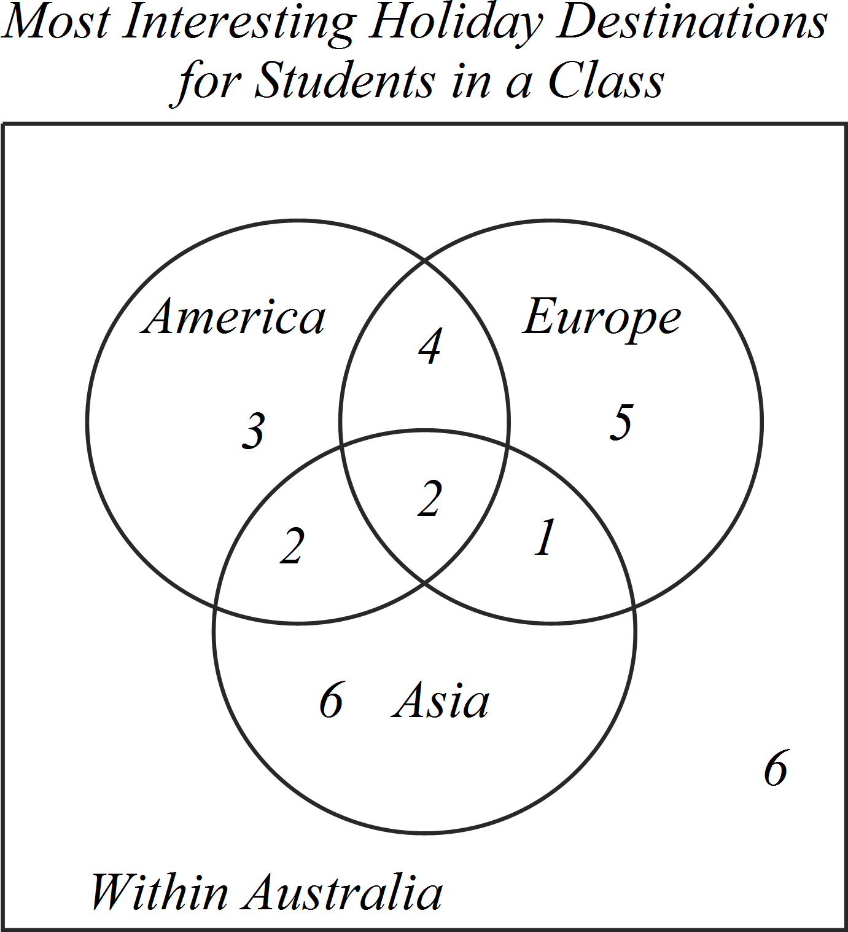
a) | How many students were in the class?
b) | What is the probability that the teacher chose a student who had been to all three overseas destinations?
c) | What is the probability that the teacher chose a student who had been to two overseas destinations, but not all three?
d) | Given the teacher only chose from those who had been overseas, what is the probability that she chose a student who had not been to Asia?

13. | [4 marks: 2, 1, 1]
 | The frequency table below shows the types of books on Carl’s bookshelf.
 | 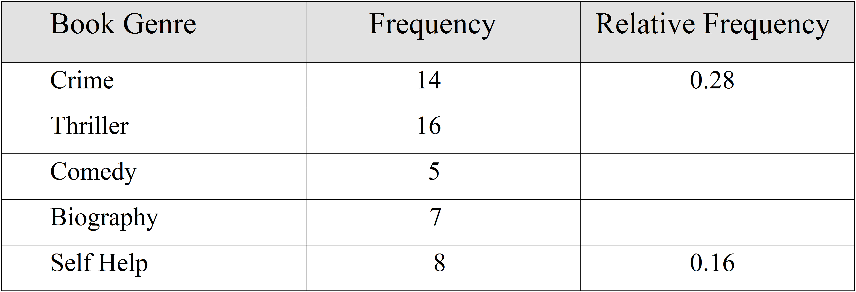
a) | Complete the relative frequency column.
b) | Carl picks a book at random from the bookshelf. What is the probability that it is a comedy book?
c) | What is the probability that a book chosen at random is not a biography?

14. | [6 marks: 2, 1, 1, 1, 1]
 | Mark had a container that held ten counters: 5 blue, 3 red and 2 green. He asked Bobby to select two counters from the container, without replacement.
a) | Draw a weighted tree diagram to show all the possible combinations of counters Bobby could select.
b) | What is the probability that:
 | i) | Bobby selected two blue counters?
 | ii) | Bobby did not select any red counters?
 | iii) | given Bobby selected a blue counter, she then selected a red counter?
 | iv) | given Bobby’s second selection is green, what is the probability that the first counter is blue?

~ END OF TEST SECTION 2 ~

